

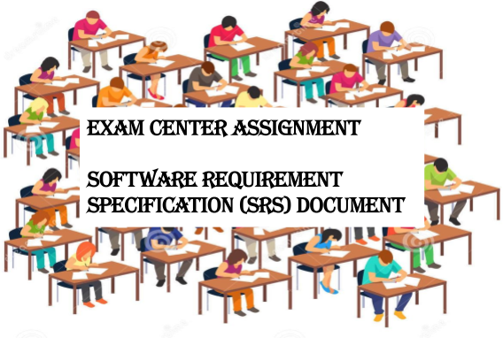

**SPRINT 1 IMPLEMENTATION**

**PROJECT TIMELINE: 26-09-22 TO 11-10-22**

|  |  |
| --- | --- |
|  |  |
| 1. **Introduction** |  |
| 1.1 Purpose | -------------------------------------------------- 3 |
| 1.2 Intended audience | -------------------------------------------------- 3 |
| 1.3 Intended use | -------------------------------------------------- 3 |
| 1.4 Scope | -------------------------------------------------- 3 |
| 2. **Overall description** | -------------------------------------------------- 3 |
| 2.1 Assumptions and dependency | ------------------------------------------------- 4 |
| 3. **System feature and requirements** | -------------------------------------------------- 4 |
| 3.1 Functions | -------------------------------------------------- 4 |
| 3.1.1 insertExamData**()**  3.1.2 processing_data() | --------------------------------------------------4  -------------------------------------------------4 |
| 3.1.3 insertCandidateData**()** | -------------------------------------------------- 4 |
| 3.1.4 writeToFile() | -------------------------------------------------- 4 |
| 3.1.5 printHallTicket() | -------------------------------------------------- 4 |
| 3.2 System requirement | -------------------------------------------------- 5 |
| 3.2.1 Tools to be used | -------------------------------------------------- 5 |
| 3.3 System feature | ------------------------------------------------- 5 |

## Data Flow Diagram

* 1. DFD level 0 6
  2. DFD level 1 7

1.



-

The introduction of the software requirement specification provides an overview of the entire software. The entire SRS with overview description purpose, scope, tools used and basic description. The aim of this document is to gather, analyze and give an in-depth insight into the complete exam center assignment application by defining the problem statement in detail. The detailed requirements of the exam center assignment application are provided in this document.

* 1. **Purpose**: **-** The purpose of this document is to show the requirements for the exam center assignment application, in which candidates will be assigned their exam center based on their exam information.
  2. **Intended Audience: -** This document is intended to be read by the client.

### Intended Use: -

* + - Development Team
    - Maintenance Team
    - Clients

Since this is a general-purpose software any one can access it.

* 1. **Scope: -** This project aims to create the development of an exam center assignment application which takes the candidate information such as name, candidateID, examID, start date and end date and adds it to the database and returns the hall ticket with the information of the respective examination center of the candidate.



-

It is an exam center assignment application which reads and stores the valid candidate data and the exam center data in a database. The application then correlates this data and assigns the respective exam center to the candidates based on the exam they will be appearing for.

The application will also store all the invalid entries in a text file and give the error message to the user.

Moreover, the application has the capability to generate a file which has the information of the candidates giving their exam in a particular exam center.

### Assumptions and Dependency: -

* + - System should have Ubuntu Linux/cygwin installed.
    - System should have either 4GB or more RAM.
    - The service is used preferably on a desktop or laptop.

●

## NOTE:- If using cygwin, we have to use putty for the usage of valgrind.



3: -

* 1. **Functions: -**
     1. **EC01-> insertExamData():** This function is the first function to be called when the application is called. It parses the exam center data from the text file and stores it in a linked list ready for further processing.
     2. **EC02-**> **processing_data():** This is the next important function called when the application is in execution. It parses the candidate details from the multiple text files. Now this function inside calls another “insertcandidatedata” func, which validates each entry from the candidate files to store "struct candidate" data in a linked list and returns 1 or 0 on success and failure. Finally this func prints all the Invalid candidates with their ids.
     3. **EC03-> insertCandidateData():** This function is used to insert candidate data while parsing it for the different fields and storing it in the list. Valid entries are tokenized and added to the list and the invalid entries are rejected and stored in a file whilst also giving the user an error message.
     4. **EC04-> writeToFile():** This function is used to assign the candidates their exam hall. It compares the values of the lists, which store only valid entries and then allocates the students their exam hall.
     5. **EC05-> printHallTicket():** This function prints the hall ticket when the user enters the candidate ID. If the candidate had entered the correct details, then they will get the hall ticket which has all the details about their exam and exam center.



-

## Tools to be used:

* + - * System Programming
      * pthread library
      * Linux
      * C Programming
      * C File Handling
      * valgrind
      * make
      * System Programming:- Systems programming covers data and program management, including operating systems, control programs, network software, and database management systems.
      * pthread library:- POSIX thread (pthread) libraries. The POSIX thread libraries are a standards based thread API for C/C++. It allows one to spawn a new concurrent process flow.
      * Linux:- Linux is used in the following ways: Server OS for web servers, database servers, file servers, email servers and any other type of shared server.
      * C Programming:- C programming language is a machine-independent programming language that is mainly used to create many types of applications and operating systems such as Windows, and other complicated programs such as the Oracle database, Git, [Python](https://www.simplilearn.com/learn-the-basics-of-python-article) interpreter, and games and is considered a programming foundation in the process of learning any other programming language.
      * C File Handling:- File handling in C enables us to create, update, read, and delete the files stored on the local file system through our C program. The following operations can be performed on a file.
      * Valgrind:- valgrind is a tool for finding memory access errors to heap memory (memory that is dynamically allocated with new or malloc) in C and C++ programs. Memory access errors are the most difficult bugs to find and to fix.
      * make**:-** The make utility requires a file, Makefile (or makefile), which defines set of tasks to be executed. You may have used make to compile a program from source code.



-

* Supportability: The system is easy to use.
* Design Constraints: The system is built using only C language.
* Usability: The exam center assignment application can be used to assign the appropriate exam center to a candidate based on the exams he wishes to attend on a particular date along with his credentials. The application is also able to generate the hall ticket containing Candidate ID, Exam ID, Candidate name, Name of college, address of exam center, start date, end date when the user enters their candidate ID.
* Reliability and availability**:** The system is available 24/7 that is whenever the user would like to use the system, they can use it up to its functionalities.
* Performance: The system will work on the user’s terminal**.**

# :

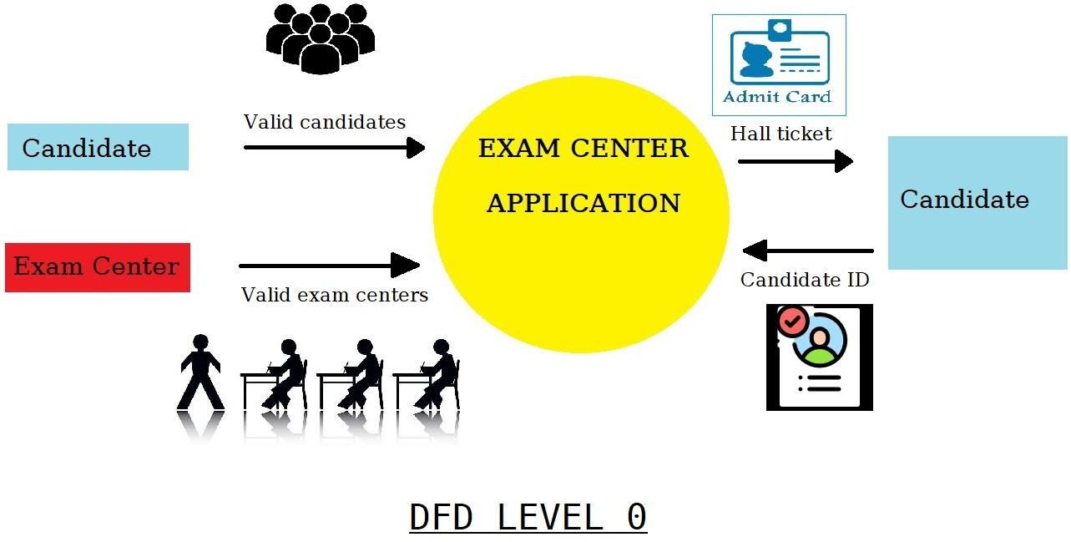

4.1

# 4.2

